
SRM Institute of Science and Technology
College of Engineering and Technology
Mode of Exam
OFFLINE
School of Computing
DEPARTMENT OF COMPUTATIONAL INTELLIGENCE
SRM Nagar, Kattankulathur – 603203, Chengalpattu District, Tamilnadu
Academic Year: 2024-2025 (ODD) SET - B
Test: CLAT-1 Date:18/07/24
Course Code & Title: 18AIE424T- ARTIFICIAL INTELLIGENCE AND INTERNET OF THINGS
Duration: 1 Hour 40 minutes
Year & Sem: IV & VII Max. Marks: 50

Course Articulation Matrix:

S.No. | Course Outcome | PO1 | PO2 | PO3 | PO4 | PO5 | PO6 | PO7 | PO8 | PO9 | PO10 | PO11 | PO12
1 | CO1 | - | - | - | - | - | - | - | - | - | - | - | -
2 | CO2 | - | - | - | - | - | - | - | - | - | - | - | -
3 | CO3 | - | - | - | - | - | - | - | - | - | - | - | -
4 | CO4 | H | - | - | H | H | - | - | - | M | L | - | H
5 | CO5 | H | - | - | H | H | - | - | - | M | L | - | H

Part - A
( 10 x 1 = 10 Marks)
Instructions: Answer all
Q. No | Question | Marks | BL | CO | PO | PI Code
1 | Given below are two statements:  Statement I: A genetic algorithm is a stochastic hill-climbing search in which a large population of states is maintained.  Statement II: In nondeterministic environments, agents can apply AND-OR search to generate contingent plans that reach the goal regardless of which outcomes occur during execution.  In the light of the above statements, choose the Correct answer from the options given below  a. Both Statement I and Statement II are true  b. Both Statement I and Statement II are false  c. Statement I is correct but Statement II is false  d. Statement I is incorrect but Statement II is true | 1 | 1 | 4 | 1,4 | 1.4.1
2 | Which of the following operation is responsible to jump from one hill to another hill?  a. Mutation  b. Cross Over  c. Fitness Function  d. Natural Selection | 1 | 1 | 4 | 1 | 1.4.1
3 | Which algorithm is particularly well-suited for environments with continuous action spaces?  - Q-Learning  - Deep Q-Network (DQN)  - Policy Gradient  - Monte Carlo Tree Search (MCTS) | 1 | 1 | 4 | 1 | 1.3.1
4 | Which algorithm combines both value-based and policy-based methods in reinforcement learning?  a. Q-learning  b. Actor-Critic  c. Monte Carlo methods  d. Deep Q-Network (DQN) | 1 | 1 | 4 | 1 | 1.3.1
5 | __________ is a component on top of Spark Core.  - RDDs  - Spark SQL  - Spark Streaming  - Spark Context | 1 | 1 | 5 | 1 | 1.3.1
6 | The primary Machine Learning API for Spark is now the _____ based API  a. Data Frame  b. Dataset  c. RDD  d. context | 1 | 1 | 5 | 1 | 1.3.1
7 | Which of the following is an example of an IoT application in home automation?  - Smart lighting system  - Online grocery delivery service  - Smart home security system  - Virtual reality entertainment system | 1 | 1 | 5 | 1 | 1.3.1
8 | In IIoT, what does the term "edge computing" refer to?  - Centralized data processing in the cloud  - Processing data at the source or near the source  - Data encryption and security measures  - Data visualization techniques | 1 | 2 | 5 | 1,4 | 1.3.1
9 | What is the role of the "latent space" in a VAE?  - It represents the input data directly.  - It stores the compressed input data.  - It is used for classification tasks.  - It calculates the reconstruction error | 1 | 1 | 4 | 1 | 1.3.1
10 | What makes H2O Driverless AI stand out in terms of machine learning automation?  - It focuses exclusively on deep learning models.  - It requires extensive manual configuration and coding.  - It automates the entire machine learning pipeline, including feature engineering and model selection.  - It is optimized for natural language processing tasks. | 1 | 2 | 5 | 1 | 1.3.1

SET B

Part – B
( 4 x 5 = 20 Marks)
Instructions: Answer any 4
11 | Describe the deterministic and analytic methods to solve optimization problems. | 5 | 1 | 4 | 1 | 2.1.1
12 | Describe the training process of a GAN. How does the generator learn to improve its output, and how does the discriminator adapt to become more discerning? | 5 | 2 | 5 | 1,5 | 2.1.1
13 | Discuss about the different components and workflow of Spark. | 5 | 2 | 4 | 1 | 2.1.1
14 | Explain how wearable sensors are used to track the human activity recognition? | 5 | 3 | 5 | 1 | 2.1.1
15 | How does the latent space of a VAE differ from the bottleneck layer of a standard autoencoder? | 5 | 1 | 4 | 1 | 2.1.1
PART – C
(2x 10 =20 Marks)
Instructions: Answer any 2
16 | a) You are training a deep neural network for a computer vision task. How might you use genetic algorithms to search for the best hyperparameters, such as learning rate, batch size, and network architecture? What would the genetic encoding and fitness evaluation involve?  OR  b)(i) In the taxi problem, how would you represent the states in the Q-learning algorithm? What are the components of a state, and how do you encode them? [5 marks]  (ii)How does the Q-value change after an iteration of Q-learning, and what role do the learning rate and discount factor play? [5 marks] | 10 | 2 | 4 | 1,5 | 2.3.1
17 | a)How does IIoT facilitate supply chain optimization and logistics management? What role does real-time tracking and monitoring play in this context?  OR  b)Explain how IoT devices address the key challenges posed by excessive urban population; they can help with traffic management, healthcare, energy crisis, and many other issues | 10 | 3 | 5 | 1,4 | 2.3.1

Course Outcome (CO) and Bloom’s level (BL) Coverage in Questions

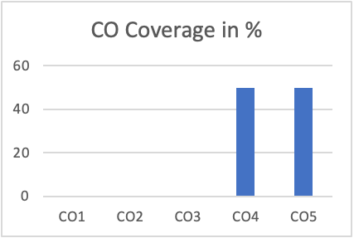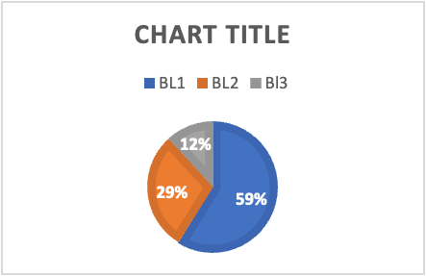
Approved by the Audit Professor/Course Coordinator

